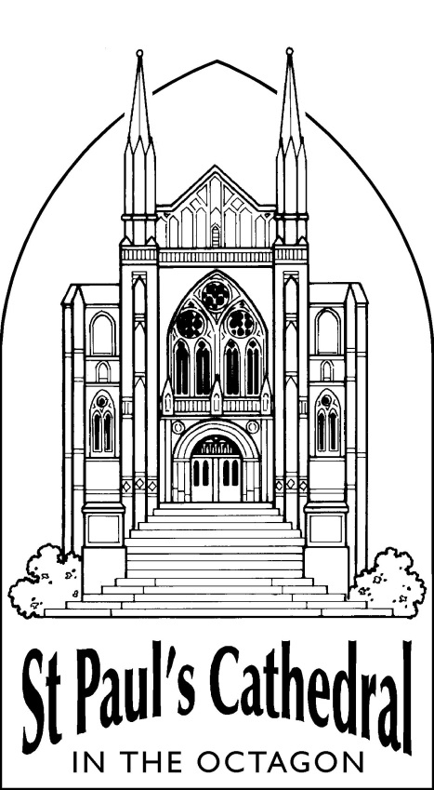

WW100 THE EMBARKATION
COMMEMORATION SERVICE
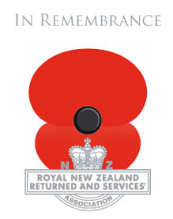

TO OUR COMRADES WHO FELL IN THE FIRST WORLD WAR

Sunday, 21st September, 2014
at 12:00 pm
THE ORDER OF SERVICE

The service will be conducted by

The Very Rev’d Dr Trevor James, Dean of St Paul’s Cathedral,
with The Cathedral Choir

Director of Music and Cathedral Organist: George Chittenden

The congregation stands for the procession, during which the following music is played and the following poem is read:

Processional Music | Nimrod from ‘Enigma Variations' Edward Elgar (1857-1934)
Poem: ‘Men who march away’ Thomas Hardy (1840-1928)

In our heart of hearts believing
Victory crowns the just,
And that braggarts must
Surely bite the dust,
Press we to the field ungrieving,
In our heart of hearts believing
Victory crowns the just.

Hence the faith and fire within us
Men who march away
Ere the barn-cocks say
Night is growing gray,
Leaving all that here can win us;
Hence the faith and fire within us
Man who march away.

written in September 1914

The Call to Worship: (The Dean)

We meet here as part of an international remembrance of the years of the First World War. Specifically today we remember the gathering of troops from throughout Otago and Southland and their assembly in Dunedin for embarkation to those places that would, too soon, become etched in our memory and carved on memorials around our nation: Gallipoli, Flanders, Ypres, The Somme. But today we remember a moment when those shadows had still to darken our world. Instead we remember the men who gathered here in an Otago Spring. They came, shutting the front door or the farm gate for the last time. On crisp mornings and in golden days they came: from towns, villages and cribs; from pubs, milking sheds, high country huts, mills, mines, and trout streams; from schools and lecture halls, corner stores, churches, offices, and homes. Our hearts can only guess what hopes they held, but this was spring: the Empire called and the world beckoned. Before God we remember those who gathered here; their loved ones; and all those lives soon to be changed forever.

Hymn: ‘All my hope on God is founded’ (Michael)

1) All my hope on God is founded;
he doth still my trust renew,
me through change and chance he guideth,
only good and only true.
God unknown, he alone
calls my heart to be his own.

2) Pride of man and earthly glory,
sword and crown betray his trust;
what with care and toil he buildeth,
tower and temple fall to dust.
But God's power, hour by hour,
is my temple and my tower.

3) God's great goodness aye endureth,
deep his wisdom, passing thought:
splendour, light and life attend him,
beauty springeth out of naught.
Evermore from his store
newborn worlds rise and adore.

4) Daily doth the almighty Giver
bounteous gifts on us bestow;
his desire our soul delighteth,
pleasure leads us where we go.
Love doth stand at his hand;
joy doth wait on his command.

5) Still from man to God eternal
sacrifice of praise be done,
high above all praises praising
for the gift of Christ, his Son.
Christ doth call one and all:
ye who follow shall not fall.

Text: Robert Bridges (1844-1930);
based on the German text of Joachim Neander (1650-1680)
The congregation kneels or sits.

Reading: Isaiah 55 (vv. 6-end)

Read by: Mr Niall Campbell

Seek the Lord while he may be found,
call upon him while he is near;
let the wicked forsake their way,
and the unrighteous their thoughts;
let them return to the Lord, that he may have mercy on them,
and to our God, for he will abundantly pardon.
For my thoughts are not your thoughts,
nor are your ways my ways, says the Lord.
For as the heavens are higher than the earth,
so are my ways higher than your ways
and my thoughts than your thoughts.
For as the rain and the snow come down from heaven,
and do not return there until they have watered the earth,
making it bring forth and sprout,
giving seed to the sower and bread to the eater,
so shall my word be that goes out from my mouth;
it shall not return to me empty,
but it shall accomplish that which I purpose,
and succeed in the thing for which I sent it.
For you shall go out in joy,
and be led back in peace;
the mountains and the hills before you
shall burst into song,
and all the trees of the field shall clap their hands.
Instead of the thorn shall come up the cypress;
instead of the brier shall come up the myrtle;
and it shall be to the Lord for a memorial,
for an everlasting sign that shall not be cut off.

The Cathedral Choir sings the Anthem:

‘So they gave their bodies’ Peter Aston (1938-2013)

‘So they gave their bodies to the Commonwealth and received praise that will never die, and a home in the minds of men. Their story lives on without visible symbol, woven into the stuff of other men’s lives. So they gave their bodies to the Commonwealth and received praise that will never die.’
Text: ‘Pericles’ Funeral Oration’ (4th Century)

Reading: ‘Peace’ Rupert Brooke (1887-1915)

Read by: Mrs Wendy Aitken

Now, God be thanked Who has matched us with His hour,
And caught our youth, and wakened us from sleeping,
With hand made sure, clear eye, and sharpened power,
To turn, as swimmers into cleanness leaping,
Glad from a world grown old and cold and weary,
Leave the sick hearts that honour could not move,
And half-men, and their dirty songs and dreary,
And all the little emptiness of love!

Oh! we, who have known shame, we have found release there,
Where there's no ill, no grief, but sleep has mending,
Naught broken save this body, lost but breath;
Nothing to shake the laughing heart's long peace there
But only agony, and that has ending;
And the worst friend and enemy is but Death.

written in 1914

Collect for The Great War Memorial Window: The Dean

Almighty God, we give thanks for the regiments of Otago and Southland remembered in this window to honour all who served and all who fell; we rejoice also at the faithful love of those benefactors throughout our region who erected this memorial that the spirit of sacrifice may not be forgotten; so, by your grace, we commit ourselves anew to following the one who sacrificed himself for all the world and rules from the Cross, your Son, Jesus Christ, our Lord. Amen.

The Cathedral Choir sings the Anthem:

‘O what their joy and their glory must be’ William Harris (1883-1973)

O what their joy and their glory must be, those endless Sabbaths the blessèd ones see; crown for the valiant, to weary ones rest: God shall be All, and in all ever blest. What are the Monarch, his court and his throne? What are the peace and the joy that they own? O that the blest ones, who in it have share, all that they feel could as fully declare! Truly, "Jerusalem" name we that shore, city of peace that brings joy evermore; wish and fulfillment are not severed there, nor do things prayed for come short of the prayer. There, where no troubles distraction can bring, we the sweet anthems of Zion shall sing; while for thy grace, Lord, their voices of praise thy blessèd people eternally raise. Now, in the meantime, with hearts raised on high, we for that country must yearn and must sigh, seeking Jerusalem, dear native land, through our long exile on Babylon's strand. Low before him with our praises we fall, of whom and in whom and through whom are all; of whom, the Father; and in whom, the Son; and through whom, the Spirit, with them ever One.

Text: Peter Abelard (12th Century), trans. John Mason Neale (1818-1866)

Reading: Revelation 21 (vv. 1-7)

Read by: Mr Bruce Aitken

Then I saw a new heaven and a new earth; for the first heaven and the first earth had passed away, and the sea was no more. And I saw the holy city, the new Jerusalem, coming down out of heaven from God, prepared as a bride adorned for her husband. And I heard a loud voice from the throne saying, “See, the home of God is among mortals. He will dwell with them as their God; they will be his peoples, and God himself will be with them; he will wipe every tear from their eyes. Death will be no more; mourning and crying and pain will be no more, for the first things have passed away.” And the one who was seated on the throne said, “See, I am making all things new.” Also he said, “Write this, for these words are trustworthy and true.” Then he said to me, “It is done! I am the Alpha and the Omega, the beginning and the end. To the thirsty I will give water as a gift from the spring of the water of life. Those who conquer will inherit these things, and I will be their God and they will be my children.

The congregation kneels or sits.

A Responsorial Prayer of Commemoration:

Remember, Lord, all those who gathered in this city for embarkation to war one hundred years ago; all those whose stories are unspoken and untold.

All: Jesus, remember them when you come into your kingdom.

Remember, Lord, all who set out from this city with high hopes and dreams in that spring of 1914.

All: Jesus, remember them when you come into your kingdom.

Remember Lord, all those whose minds were darkened and disturbed by memories of war.

All: Jesus, remember them when you come into your kingdom.

Remember, Lord, those who suffered in silence, and those whose bodies were disfigured by injury and pain.

All: Jesus, remember them when you come into your kingdom.

Father of all, remember your holy promise, and look with love on all your people, living and departed. On this day we especially ask that you would hold for ever all who suffered during the First World War, those who returned scarred by warfare, those who waited anxiously at home, and those who returned wounded, and disillusioned; those who mourned, and those communities that were diminished and suffered loss. Remember too those who acted with kindly compassion, those who bravely risked their own lives for their comrades, and those who in the aftermath of war, worked tirelessly for a more peaceful world. And as you remember them, remember us, O Lord; grant us peace in our time and a longing for the day when people of every language, race, and nation will be brought into the unity of Christ’s kingdom. This we ask in the name of the same Jesus Christ our Lord. Amen.

The Lord’s Prayer: You are invited to say the Lord’s Prayer in the language of your choice.

Our Father in heaven,  hallowed be your name,  your kingdom come,  your will be done,  on earth as in heaven.  Give us today our daily bread.  Forgive us our sins  as we forgive those  who sin against us.  Save us from the time of trial  and deliver us from evil.  For the kingdom,  the power,  and the glory are yours  now and for ever. Amen. | E tō mātou Matua i te rangi  Kia tapu tōu Ingoa.  Kia tae mai tōu rangatiratanga.  Kia meatia tāu e pai ai  ki runga ki te whenua,  kia rite anō ki tō te rangi.  Hōmai ki a mātou āianei  he taro mā mātou mō tēnei rā.  Murua ō mātou hara,  Me mātou hoki e muru nei i ō te hunga  e hara ana ki a mātou.  Āua hoki mātou e kawea kia whakawaia;  Engari whakaorangia mātou i te kino:  Nōu hoki te rangatiratanga, te kaha,  me te korōria, Āke āke āke. Āmine.

The congregation stands for The Offertory Hymn, during which time a collection will be taken to support the life and work of this Cathedral Church.

Offertory Hymn: ‘Morning glory, starlit sky’ (Morning Glory)

1) Morning glory, starlit sky,
soaring music, scholars' truth,
flight of swallows, autumn leaves,
mem'ry's treasure, grace of youth.

2) Open are the gifts of God,
gifts of love to mind and sense;
hidden is love's agony,
love's endeavour, love's expense.

3) Love that gives, gives evermore,
gives with zeal, with eager hands,
spares not, keeps not, all outpours,
ventures all, its all expends.

4) Drained is love in making full,
bound in setting others free,
poor in making many rich,
weak in giving power to be.

5) Therefore he who shows us God
helpless hangs upon the tree,
and the nails and crown of thorns
tell of what God's love must be.

6) Here is God: no monarch he,
throned in easy state to reign;
here is God, whose arms of love,
aching, spent, the world sustain.

Text: W. A. Vanstone (1923-1999)

The congregation remains standing.

The Blessing: The Dean

God grant to the living, grace; to the departed, tranquillity; to the Church, the Queen, the Commonwealth and all humanity, peace and concord; and to us and all His servants, life everlasting. And the blessing of God Almighty, the Father and the Son and the Holy Spirit, be with us, and remain with us always. Amen.

Hymn: ‘Honour the dead, our country’s fighting brave’

1) Honour the dead, our country’s fighting brave,
honour our children left in foreign grave,
where poppies blow and sorrow seeds her flowers,
honour the crosses marked forever ours.

2) Weep for the places ravaged with our blood,
weep for the young bones buried in the mud,
weep for the powers of violence and greed,
weep for the deals done in the name of need.

3) Honour the brave whose conscience was their call,
answered no bugle, went against the wall,
suffered in prisons of contempt and shame,
branded as cowards, in our country’s name.

4) Weep for the waste of all that might have been,
weep for the cost that war has made obscene,
weep for the homes that ache with human pain,
weep that we ever sanction war again.

5) Honour the dream for which our nation bled,
held now in trust to justify the dead,
honour their vision on this solemn day:
peace known in freedom, peace the only way.

Text: Shirley Murray (1931-)

Voluntary: Imperial March Edward Elgar (1857-1934)

The Great War Memorial Window

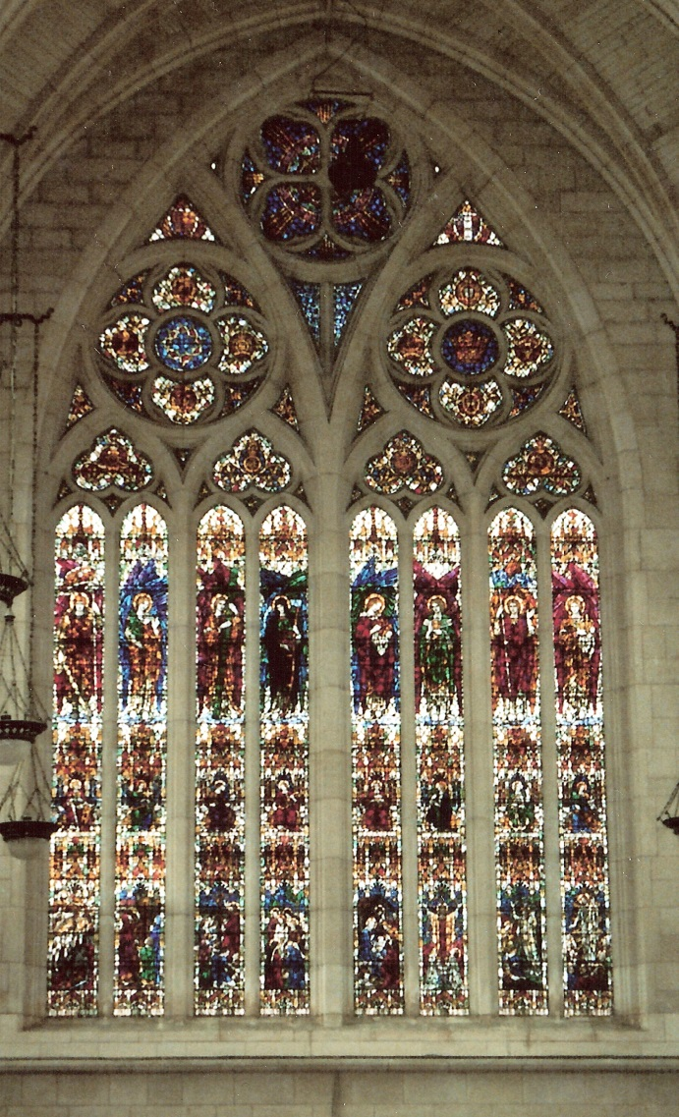

The window was made by James Powell and Son, Whitefriars, London. The window represents Victory (right-hand half) through Sacrifice (left-hand half) symbolised by the Golden Crown and the Crown of Thorns respectively in the upper tracery. Within the tracery sections are the Coats of Arms of the Otago and Southland Regiments, and the Arms of New Zealand and the United Kingdom.
The top line of figures consists of (1) St. Michael the Warrior Angel; (2) the Angel of Suffering; (3) Sacrifice; (4) Death; (5) Gabriel the Archangel of Peace; (6) Angel with Chalice of Remembrance; (7) of the Resurrection; and (8) Victory with the Crown of Glory.
The central line symbolises Fortitude, Patience, Truth, Obedience, Love, Faith, Hope, and Peace.
The bottom line uses new symbols for the top themes: War in Heaven, the Pascal Lamb, Moses lifting up the serpent in the wilderness, the Entombment, the Nativity, Christ reigning from the Cross, and the Resurrection and Ascension.

